**MISIS industrial partners and employment assistance** (Глеб)

1. **MISIS industrial partners**

Industrial partners of MISIS university are companies that collaborate closely with the university and often hire its graduates for their projects.

Among MISIS partners there are many famous companies such as:

* BearingPoint - business consulting company
* 1C - software developing company
* Loginom - IT company which created “Loginom analytical tool”

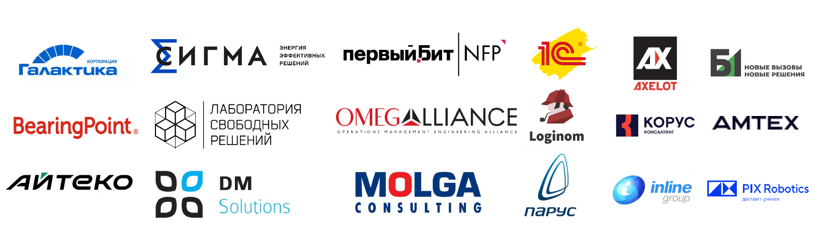

1. **How to get hired at MISIS?**

In order to get hired MISIS student should:

* study well and pass all exams successfully
* Visit “Introduction to specialty course”, because companies visit us here and announce internship and job opportunities.

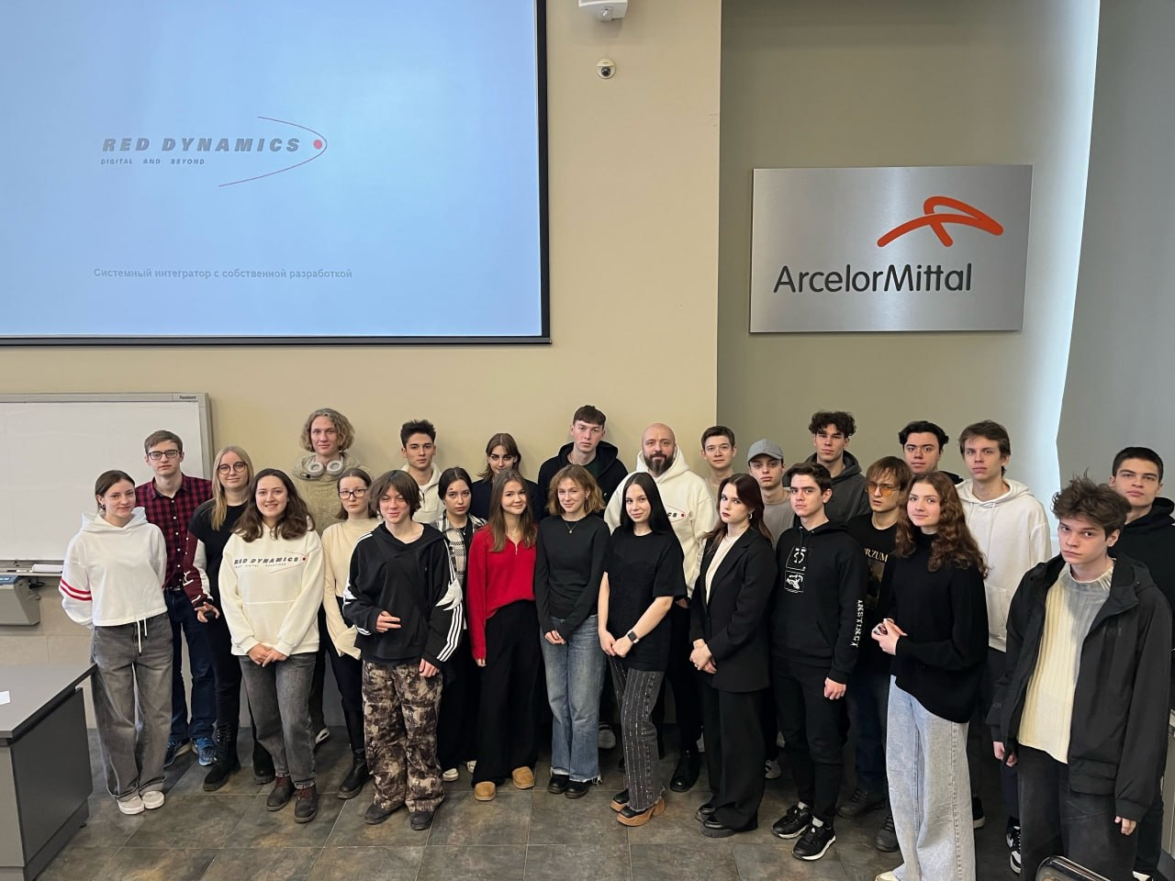

For instance, in the previous week we had a meeting with the Red Dynamics company.

1. **Student employment statistics**

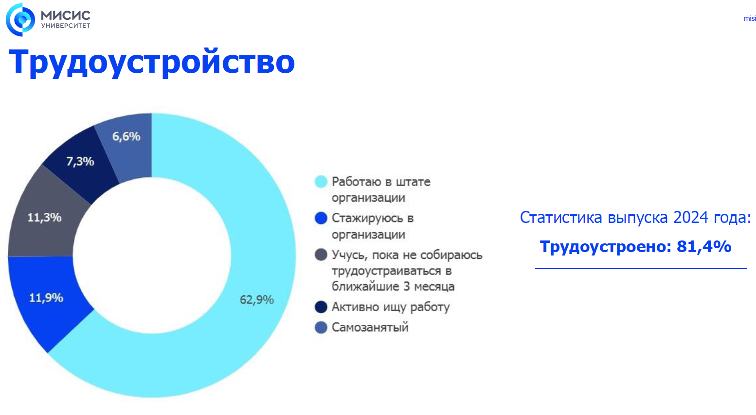

According to MISIS student employment statistics in 2024:

62% of students are hired and work in companies

12% are currently on an internship in companies

7% are self-employed

1. **Success cases**

To conclude the employment assistance of MISIS University I want to mention some success cases:

* Our dear mentor Karina Elesina - head business analyst.
* Ulyana Valerievna - Analyst-developer at Elma365
* Ilya Olegovich - Project Manager

Нека: